**DAILY ONLINE ACTIVITIES SUMMARY**

|  |  |  |  |  |  |  |  |  |
| --- | --- | --- | --- | --- | --- | --- | --- | --- |
| **Date:** | **17/06/2020** | | | | | **Name:** | **Likhitha.M** | |
| **Sem & Sec** | **6th A** | | | | | **USN:** | **4al17cs046** | |
| **Online Test Summary** | | | | | | | | |
| **Subject** | | **C-operator and storage class** | | | | | | |
| **Max. Marks** | | **15** | | **Score** | | | **11** | |
| **Certification Course Summary** | | | | | | | | |
| **Pre placement training** | **9:00 am to 11:00 am - Programming in C**  **11:00 am to 1:00pm - Applications of python in DA and ML** **4:00 pm to 5:00 pm – webinar on Blockchain Technology** | | | | | | | |
| **Faculty** | | | **Vivek Sharma,**  **Dr.Mohideen Badusha** | | **Duration** | | | **4hrs.** |
| **Coding Challenges** | | | | | | | | |
| **Problem Statement:**   1. Examples and Exercises on python.   .  **2.**    **..**  **2. Write a simple code to identify given linked list is palindrome or not by using stack. First take a Stack. Traverse through each node of the linked list and push each node value to Stack.** | | | | | | | | |
| **Status: Completed** | | | | | | | | |
| **Uploaded the report in Github** | | | | | **yes** | | | |
| **If yes Repository name** | | | | | **https://github.com/likhithaMantaral/Python-in-DA_-and_-ML/blob/master/Day3-session2-exercise%20problrms.ipynb** | | | |
| **Uploaded the report in slack** | | | | | **yes** | | | |

C -operator and storage class(workshop quiz):

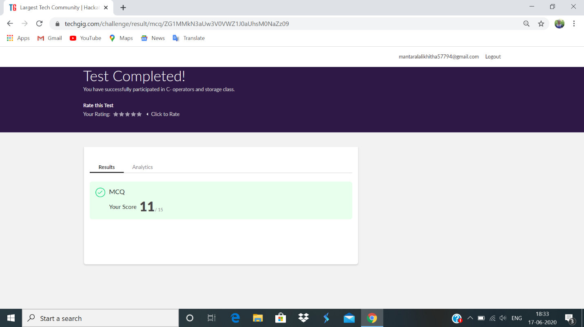

Training snapshot:

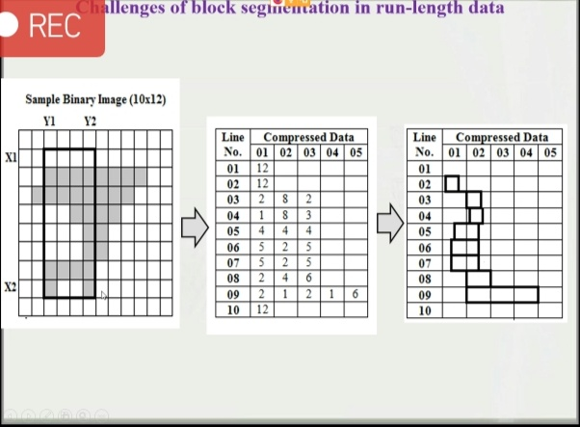

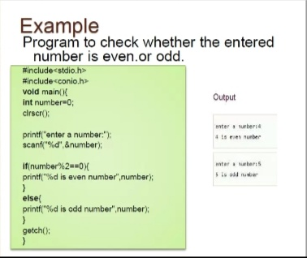

**Webinar:**

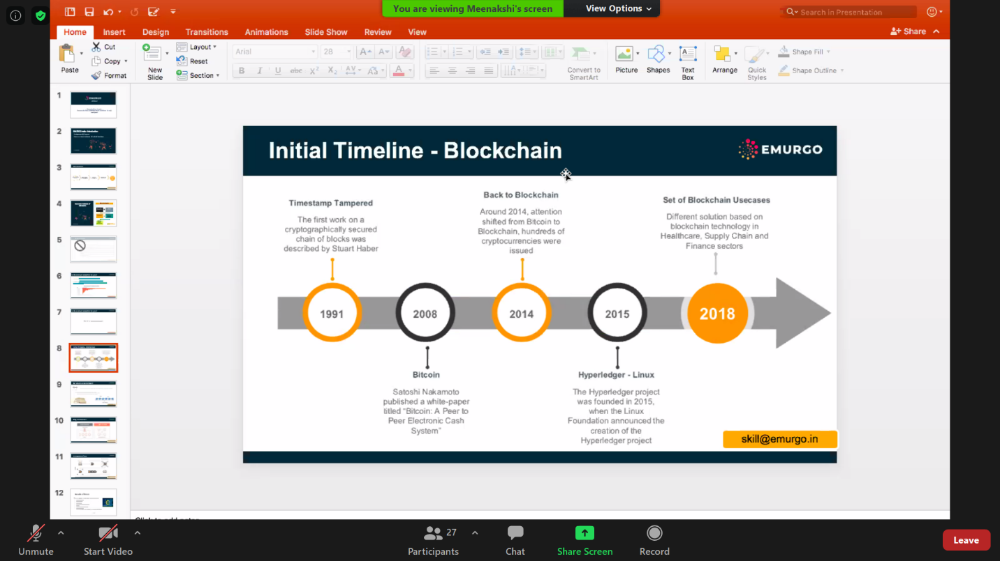

**Assessments:**

**Uploaded in Github account and respective links are provided.**

